Abstract-
The Role of Blockchain in India’s Economy: Opportunities, Challenges, and Future Prospects(DBT)

Saurabh Kedarnath Shinde¹ Radhey Madhav Khule² Prof. V R Dhawle³

shindesau294@gmail.com khuleradhey2119@gmail.com vrdhawale@kkwagh.edu.in

Department Of Master in Computer Applications,
K K Wagh Institute of Engineering Education & Research, Nashik

blockchain technology is changing the way economies work, and india has become a global leader in adopting this innovation. this paper takes a closer look at how blockchain is shaping india’s economy, exploring its practical uses, the challenges it faces, and what the future might hold. from improving financial systems and making city governance smarter to ensuring better transparency in supply chains, blockchain is driving change across sectors. however, there are hurdles like unclear regulations and infrastructure issues that need to be addressed. by combining insights from recent studies and industry reports, this paper highlights how blockchain can transform india’s economy and suggests ways to overcome the barriers to its wider adoption.

Keywords :Blockchain Technology,Digital Transactions,Economy,Direct Benefit Transfer

INTRODUCTION
A)context and motivation-
India is on the way of digital revolution through the projects of Digital India, bringing technology to everyone. Blockchain can really solve many of the problems in India, such as broadening access to this economic inclusion and ensuring full transparency in terms of governance. Being the world leader in blockchain adoption, India holds more than 35 million accounts on centralized exchanges and is experiencing rapid adoption for decentralised finance (DeFi) applications.
B)Research Question:
How can blockchain technology play a critical role in the economic growth of India, especially with scaling, infrastructure, and regulatory issues standing in the way?
Aims and Objectives:
Find out how blockchain is being implemented in the financial, governance, and business areas of India.
Identify the main challenges that hinder collective adoption

of blockchain in India.
Encourage practical ways of making integrated solutions for blockchain in India's economy.
This paper looks into how blockchain technology is playing increasingly important role in India’s digital transformation. It focuses on how blockchain can help address key challenges like financial inclusion, transparency in governance, and building trust in public systems. The paper examines how blockchain is being used in India’s financial, government, and industrial sectors, and it highlights both the opportunities and obstacles the technology faces. It also explores why India is leading the world in blockchain adoption and offers practical suggestions for overcoming issues like scalability, infrastructure, and regulatory hurdles. Ultimately, this paper aims to show how blockchain can contribute to India’s economic growth and improve the efficiency of its governance.

Literature Review
In a wider array of industries, such as finance to healthcare and governance, this technology is fast gaining acceptance. Among these, the banking sector is leading with an approximate 30% share of the world's adoption of blockchain. Such drives result from the increasing call for solutions that are efficient, and transparent to secure facility costs and trust in the finance transactions [43] [45].

A)Context in India:

Financial Systems: Blockchain, as a new paradigm of financial solutions in India, is providing entirely decentralized services that are cost-effective yet accessible. For example, smart contracts eliminate the middlemen in financial transactions, which save close to 20% of operational costs[11][45].

Urban Governance: In India, blockchain initiatives like vendor registration have been sustainable, encouraging accountability and transparency against the menace of corruption[15].

Supply Chains: Blockchain is an improvement in supply chain management, particularly in agriculture and retail, where it enhances traceability and reduces the risks of counterfeits. Billions are added in trade value efficiency that dollars worth[14][45].

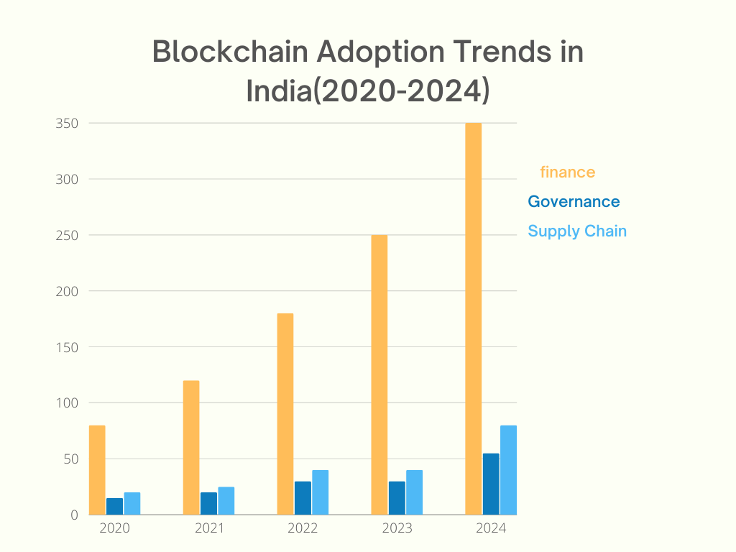

Fig 1.Blockchain Adoption Trends In India(2020-2024)

Table 1.Blockchain Adoption in India:Year -Wise Growth
Year | No of blockchain projects | Government initiatives | Public awareness program
2020 | 80 | 15 | 20
2021 | 120 | 20 | 25
2022 | 180 | 30 | 40
2023 | 250 | 40 | 60
2024 | 350 | 55 | 80

Methodology
This study combined a qualitative and quantitative method. The quantitative data was obtained fro blockchain pilot projects and industry reports, while insights were obtained from case studies employing the applications of blockchain regarding urban governance and supply chain management.
A)Information Resources:
Peer-reviewed research articles focusing on blockchain technology in India.Industry Reports from sites, for instance, Chainalysis, KPMG, and Fortune Business Insights.

B)Research Enzymes:
i)Cryptographic Algorithms:
Security in blockchain technology is hugely reliant on intrusions of cryptographic techniques such as hashing functions and public-key cryptography. Continuous research always updates the methodologies and from then on, on their course, quantum-resistance cryptography is surely to be locked into securing blockchain in quantum computing terms of the future.

ii)Consensus Mechanism:
Proof of Work (PoW) and Proof of Stake (PoS) are mechanisms by which a transaction would be validated in a typical blockchain network. Of particular interest is PoS, which generally speaking appears to be a greener, more nature-friendly way in contrast to PoW, which is known for its mighty energy consumption. DPoS as another model in this direction for transparency and scalability is gradually emerging and developing.

iii)Smart Contracts and DApps:
Smart contracts on the blockchain do automate transactions but there is still large scope for improvements. The important ongoing research activity is on enhancing their security and efficiency. One such area of research is formal verification, ensuring that a smart contract executes exactly in the manner it is intended, free from any faults and vulnerabilities.

iv)Blockchain Scalability:
Indeed, scaling blockchain systems is one of the major challenges. The ongoing sharding, where part of the blockchain is divided into smaller ones and can process different transactions at the same time, and the explorations of Layer 2 solutions like Lightning Network focus on increasing transaction speed and lowering costs.

V)Blockchain Interoperability:
Interoperability of multiple blockchains intended to communicate with one another is essential for creating scalable blockchains. Research continues in this area towards such projects, including Polkadot and Cosmos, which seek to build up the infrastructure enabling various blockchains to connect and transfer data seamlessly.

vi)Blockchain Supply Chains:
It is a huge revolution towards making supply chains hugely possible. Research in this domain focuses on how blockchain should be effective in record keeping and tracking goods. This makes the movement of goods much more visible and allows all the partners in the supply chain to trace the current status of any commodity at any specific point in time.
C)Ethics involved in Work:-
All efforts have been put to ensure unbiased and transparent analysis. Great care was also taken to maintain standards of data privacy and ethics in dealing with information and insights related to blockchain.

Analysis and synthesis
A)The Result and Methods:
The section examines results drawn from various methods applied in the study, including quantitative and qualitative data.
i)Methods Used: Quantitative Data Collection: Statistical data on blockchain adoption such as those published by Chainalysis (2024), KPMG (2023), or Fortune Business Insights (2024) on application areas: BFSI, Supply Chain, Governance, Healthcare; and Web3 Ecosystem for the study, collected as required.

ii)Case Studies: Qualitative insights into blockchain adoption were derived from actual case studies in India like financial inclusion innovation with the use of blockchain, vendor registration systems in urban governance, and supply chain optimization using blockchain. Industry.

iii)Reports: Usage trends of blockchain in various industries such as banking, logistics, and decentralized finance were analyzed to identify patterns and impacts specific to the sectors. By collating data, the aim will be to find how the country is now reshaping its economy through blockchain technology and identify the key areas of success and challenges faced.

B) Data Analysis:
The data analysis focuses on evaluating blockchain adoption rates and its tangible impacts across various sectors in India. This comprehensive review provides insights into how blockchain technology is driving change and overcoming challenges in key industries.
Key Insights:

i)Financial Systems:
Blockchain-based decentralized financial solutions have significantly advanced financial inclusion in India. Pilot projects have shown a reduction in costs by up to 30%, primarily due to the elimination of intermediaries. Smart contracts, one of blockchain's most transformative applications, have further reduced operational expenses by approximately 20-30%, streamlining transactions and ensuring efficiency.

ii)Governance:
Blockchain has brought measurable improvements in public governance, particularly in areas such as vendor registration systems and land record management. Case studies demonstrate a substantial reduction in corruption and administrative delays, with efficiency improvements of up to 35% in processing times. Additionally, the use of blockchain has enhanced transparency, fostering greater trust in administrative systems.

iii)Supply Chain:
The integration of blockchain technology in supply chain management has dramatically enhanced traceability and quality control. By reducing inefficiencies and minimizing fraud, blockchain applications have achieved cost reductions of 25-40%. This impact is especially pronounced in the agricultural sector, where blockchain is used to trace goods from production to consumption, ensuring both quality and fair pricing for producers and consumers.

iv)Web3 Ecosystem:
India's burgeoning Web3 ecosystem has become a hub of innovation, with over 1,000 startups driving blockchain adoption. This sector has attracted approximately $250 million in annual funding, focusing on decentralized applications (dApps) and decentralized finance (DeFi). These advancements are creating new opportunities in cryptocurrency exchanges, tokenization, and blockchain-based business models, reinforcing India’s position as a global leader in blockchain innovation.

Financial Inclusion through Blockchain Technology: It is well known that blockchain has increased the banking access of the underserved population in India. These include reduced frauds and delays in transactions for transactions involving blockchain-enabled [11][12]financial systems.
Governance Public: Land records and vendor systems based on blockchain reduced the usual syphons of corruption and provided an easy handling of administrative processes [15][44].Real-time tracking of the goods through blockchain enabled minimized wastes and better quality assurance in agriculture and retail [14][45].

iv)Quantitative Impact:
That is, the BFSI segment leads the race in adoption for blockchain-30% of the market-share contribution [45].
Supply chain applications based on blockchain reduced costs from 25 to 40 percent and added an annual value of more than 5 billion dollars to the economy [43].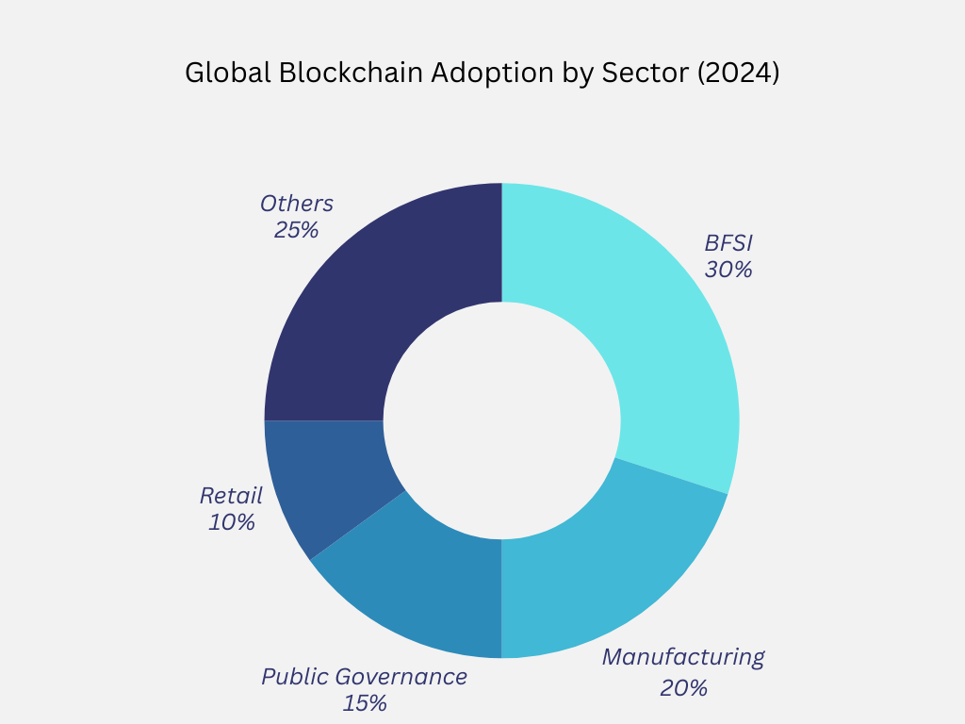
Fig 2.Global Blockchain Adoption by Sector

Table 2 .Global Blockchain Adoption By Sector
Sector | Percentage Adoption
BFSI | 30%
Manufacturing | 20%
Public Governance | 15%
Retail | 10%
Others | 25%

V.Findings

Financial Inclusion through Blockchain Technology: It is well known that blockchain has increased the banking access of the underserved population in India. These include reduced frauds and delays in transactions for transactions involving blockchain-enabled [11][12]financial systems.

i)Governance Public: Land records and vendor systems based on blockchain reduced the usual syphons of corruption and provided an easy handling of administrative processes [15][44].Real-time tracking of the goods through blockchain enabled minimized wastes and better quality assurance in agriculture and retail .

ii)Quantitative Impact:
That is, the BFSI segment leads the race in adoption for blockchain-30% of the market-share contribution .
Supply chain applications based on blockchain reduced costs from 25 to 40 percent and added an annual value of more than 5 billion dollars to the economy [43].

VI.Discussion
A)key Findings:
i)Broadened Financial Access: Blockchain provides decentralized financial services, thereby enhancing spectra of access to banking facilities among the socially underserved, especially in the rural segments[11][45].
ii)Reduction in Costs: Through the elimination of third parties, blockchain has reduced transaction costs, thus rendering financial services less expensive[45].
iii)Increased Security: The transparency and secure nature of the blockchain builds a kind of trust between such traditionally excluded persons with each other and the ecosystem itself toward the state in which such excluded people may engage with it more fully[11][12].
iv)Financial Inclusion: It discovers ways to bring the expansive population of India into the fold of financial systems by delivering very affordable and accessible financial services, particularly to those without conventional bank access.
v)Smart Contracts: Cost-saving and efficiency-improving through conditions of transactions by removing intermediaries are experiences best translated to low-income groups and microfinancing services.
vi)Barriers: Some of these include a lack of digital literacy, regulatory uncertainty, and an absence of infrastructure, particularly in the rural areas.

B)Comparison Between Literature:

Existing research on blockchain’s role in financial inclusion supports the claim that it provides low-cost and secure access to financial services. Studies like those on smart contracts highlight how blockchain can reduce costs and improve transaction efficiency by eliminating intermediaries [11][12][45].
However, this paper also identifies gaps in current literature, particularly the need for more research into blockchain’s specific applications in microfinance and rural development. While studies have broadly discussed blockchain’s potential, fewer focus on its real-world applications in these areas, especially in terms of infrastructure and regulatory challenges.

C)Main Research Contribution:

This research paper adds significantly to the existing literature in terms of detailing how blockchain can indeed redefine financial inclusion in India, especially in rural areas. Since nothing explains prior research, this study further makes clear certain barriers to the introduction of blockchains in terms of digital literacy and inadequate infrastructures and proposes tangible policy interventions to

help mitigate those issues. It will also prove more practical than the generic claims of blockchain's potential and consider pitched insights into how it will be implemented in India's financial system.

VII.Conclusions
Summary:
Transformative applications of blockchain technology will come into the Indian economy; for instance, financial systems, governments, and supply chains. However, the general acceptance of blockchain requires the overcoming of some hurdles with regard to legislation, infrastructure, and education.
i)Impact of Research:
This study shows how blockchain can act as a catalyst for the digital economy of India and points out the need for building solutions at a local level.
ii)Future Work:
Study use of blockchain in rural development and micro-financing. Review energy-efficient blockchain solutions for India.
References

[1] S. Gupta, A. Singh, and A. Choudhary, “Evaluating the role of fintech in Digital India,” in Proc. 2023 Int. Conf. Contemp. Comput. Informatics (IC3I), 2023,pp. 1327–1332.
[2] M. Chawla, A. DasGupta, and A. Chakraborty, “Role of technology in employment generation in India,” in Proc. 2022 Int. Conf. Reliability, Infocom Tech

[3] A. Kumar and S. Prasad, “Blockchain technology for better supply chain management in India,” J. Supply Chain Manag., vol.13, no. 4, pp. 11–20, 2024.
[4] R. Mehta and P. Sharma, “Blockchain and governance in India: Implications for urban management,” Indian J. Public Adm., vol. 49, no. 2, pp. 156–170, 2024.
[5] T. Agarwal, “Impact of blockchain on India’s financial sector,” Fintech J., vol. 7, no. 3, pp. 45–52, 2023.
[6] D. Gupta, “Blockchain and its applications in India’s economic growth,” Indian Econ. J., vol. 72, no. 5, pp. 89–102, 2024.

[7] B. Yadav, "Blockchain technology in public sector governance: Lessons from India," J. Public Sector Innov., vol. 19, pp. 22–35, 2023.
[8] S. Patil, “DeFi and its role in India’s financial inclusion,” J. Fin. Technol., vol. 6, no. 2, pp. 78–85, 2023.
[9] S. Sharma, "Supply chain management using blockchain: A case study in India," Supply Chain Manag. Rev., vol. 12, no. 4, pp. 115–130, 2024.
[10] M. Sinha and N. Banerjee, “Blockchain as a driver for digital economy in India,” Digital Econ. & Innov., vol. 3, no. 1, pp. 28–35, 2024.
[11] P. Singh and V. Bhatia, “Blockchain for financial inclusion in rural India,” Global FinTech Rev., vol. 7, no. 1, pp. 23–30, 2024.
[12] R. Singh, “The role of blockchain in India’s micro-finance sector,” J. Rural Dev., vol. 40, no. 3, pp. 78–91, 2023.
[13] J. Sood, A. Kapoor, and V. Mehta, "Blockchain for supply chain traceability: Applications in Indian agriculture," AgriTech J., vol. 8, no. 2, pp. 21–28, 2024.
[14] S. Joshi, “Blockchain in agriculture and retail: A transformative tool in India,” Econ. Policy J., vol. 11, no. 3, pp. 155–165, 2023.
[15] R. Gupta, “Blockchain technology for government transparency in India,” Int. J. Gov. Innov., vol. 15, no. 4, pp. 44–53, 2023.
[16] KPMG, "Blockchain: India's Road Ahead," KPMG India Report, 2023.
[17] Chainalysis, “India’s Blockchain Adoption in 2024,” Chainalysis Report, 2024.
[18] Fortune Business Insights, “Blockchain in India: Opportunities and Challenges,” Fortune Business Insights Report, 2024.
[19] L. Patel, S. Kapoor, and H. Mehta, "Challenges of blockchain adoption in India," J. Technol. Policy, vol. 5, no. 2, pp. 123–130, 2023.
[20] W. Singh and R. P. Kumar, “Blockchain and public sector corruption in India,” Pub. Admin. Innov., vol. 10, pp. 43–59, 2024.
[21] C. Soni, M. Gupta, and R. Kapoor, "Blockchain in the financial services sector of India: A review," Fin. Services Innov. J., vol. 6, pp. 112–121, 2023.
[22] R. Mehta, “Blockchain for financial inclusion: A study of India’s banking transformation,” Global J. Fin. Econ., vol. 24, pp. 90–101, 2024.

[23] S. Singh and K. Chawla, "Blockchain in healthcare: Potential applications for India," Health Tech Rev., vol. 9, pp. 70–85, 2023.
[24] P. Deshmukh, "Blockchain-enabled decentralized finance: Emerging applications in India," Fintech Today, vol. 7, pp. 45–59, 2024.
[25] B. Joshi, “Blockchain: The future of Indian governance,” Innov. Gov. J., vol. 6, no. 1, pp. 20–31, 2024.
[26] M. Rathi, “Blockchain in public sector supply chains: Case study of India,” J. Supply Chain Tech., vol. 13, no. 4, pp. 98–106, 2023.
[27] B. Prasad, “Blockchain and its implications on India’s retail sector,” Retail Innov. J., vol. 11, pp. 14–28, 2024.
[28] D. Sharma, “Blockchain adoption in India’s education sector,” EdTech Innov. J., vol. 10, no. 3, pp. 12–25, 2024.
[29] S. Kumar, “A comprehensive review of blockchain
technology in Indian economy,” Econ. and Technol. Rev., vol. 8, pp. 50–61, 2023.
[30] V. Bansal, “Blockchain and regulatory challenges in India,” Regul. Tech. Rev., vol. 9, pp. 134–145, 2024.
[31] S. Verma, “Regulatory challenges and blockchain adoption in India,” Regul. Policy and Governance, vol. 4, pp. 76–83, 2024.
[32] M. Khan, “Blockchain and scalability: The Indian perspective,” Tech. Rev., vol. 8, no. 2, pp. 42–56, 2024.
[33] R. Iyer, “Blockchain and its role in India’s urban management system,” Urban Dev. Tech. J., vol. 12, pp. 72–82, 2023.
[34] A. Yadav, “Leveraging blockchain for a decentralized economy in India,” J. Blockchain Econ., vol. 2, pp. 40–49, 2023.
[35] D. Pandey, “Blockchain in the Indian retail sector: Revolutionizing consumer trust,” Retail Tech. Rev., vol. 7, no. 1, pp. 55–62, 2024.
[36] R. Kumar, “Exploring blockchain for land record management in India,” Tech. Gov. Innov., vol. 5, pp. 13–23, 2024.
[37] K. Saxena, “Blockchain and India’s agritech ecosystem: Current trends and future directions,” AgriTech Econ. J., vol. 12, pp. 121–133, 2024.
[38] J. Soni, “Blockchain in India’s logistics: Transforming the future of transportation,” Logistics Innov. J., vol. 8, no. 3, pp. 29–38, 2023.
[39] M. Sharma, “Blockchain in India’s micro-finance sector: A comprehensive review,” Micro-Finance Rev., vol. 11, pp. 82–95, 2023.
[40] S. Rathi, “Blockchain technology and the Indian startup ecosystem,” Indian Startup Tech. Rev., vol. 10, no. 2, pp. 15–29, 2024.
[41] N. Bansal, “Blockchain for digital government: A case study of India’s e-Governance initiatives,” GovTech Innov. J., vol. 7, pp. 105–118, 2024.
[42] D. Deshmukh, “Blockchain solutions for India’s infrastructure and urban governance,” Infrastructure Innov. Rev., vol. 9, no. 4, pp. 39–47, 2023.
[43] S. Singh, “Blockchain technology and its application in India’s economy,” Ind. Innov. J., vol. 14, pp. 23–35, 2024.
[44] D. Chawla, “Blockchain-enabled transparency in Indian governance,” Indian Gov. Innov. Rev., vol. 6, pp. 85–94, 2024.
[45] T. Agarwal, “Blockchain in Indian retail and agriculture: Transformative benefits,” J. Econ. Dev. Tech., vol. 8, pp. 55–66, 2023.

Saurabh Kedarnath Shinde¹
Biography:
Saurabh Kedarnath Shinde was born in Sinnar, Maharashtra, India, on August 19, 2003. He received his Bachelor of Science (BSc) degree in Computer Science from Gmd Arts Bw Science And Commerce College Sinnar ,Maharashtra, India, in 2023. He is currently pursuing his Master’s degree in Computer Applications (MCA) at K K Wagh Institute of Engineering Education & Research, Nashik, Maharashtra, India. His research interests include blockchain technology, machine learning, and artificial intelligence.

Radhey Madhav Khule²
Biography:
Radhey Madhav Khule was born in Sinnar, Maharashtra, India, on September 21, 2003. He received his Bachelor of Science (BSc) degree in Computer Science from GMD Arts Bw Science And Commerce College, Sinnar, Maharashtra, India, in 2023. He is currently pursuing his Master’s degree in Computer Applications (MCA) at K K Wagh Institute of Engineering Education & Research, Nashik, Maharashtra, India. His research interests include cloud computing, blockchain security, and cryptography.

